W2D1 Homework Answers

* 1. **Collections** is the utility class containing methods that do certain operations related to Collection.
  2. **Collection** interface is the root interface in the collection hierarchy which represents a group of object.
  3. **List** interface allows duplicate elements and allows inserting elements at specified index.
  4. **Set** interface does not allow duplicate elements and can be used to compare elements.
  5. **Map** shows elements with their key and value.
  6. **ArrayList** – is an implementation of the list interface that uses the array’s characteristics. Allows quick adding of elements at the end but slow when in the front. This also allows the array to be resizeable.
  7. **LinkedList** – is also an implementation of the list interface but is slower when adding elements at its last part.
  8. **HashMap** – hashmap is an implementation of map that does not require ordering on keys or values.
  9. **TreeMap** – Usually ordered by key unlike hashmap.

1. **2**

Hello

Java

Learn

World

Hello

Java

Learn

World

Hello

Java

Learn

World

**2.3**

Change line number 5, from new ArrayList(); to  


new LinkedList():

**ArrayList** is an implementation of the list interface that uses the array’s characteristics. Allows quick adding of elements at the end but slow when in the front. This also allows the array to be resizeable. On the other hand, a **linkedlist** allows insertion or removals using iterators but only sequential access of elements. This makes the linkedlist slow when finding a specific position in the list depending on the size of the list.

**2.4**

Modify line number 5, change from new ArrayList(); to



**Arraylist** allows non synchronization unlike **vectors** which needs to be sychronized

1. Hello

Learn

1. (3) Compile and run well, and output 3

**5.1**

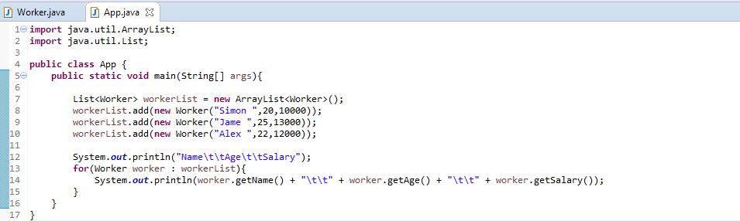

**5.2**



**5.3**

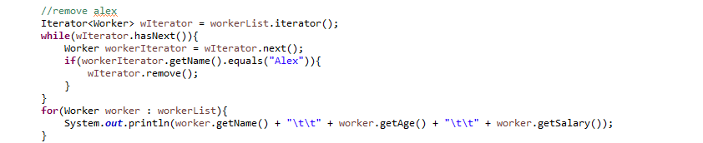

**5.4**



**5.5**

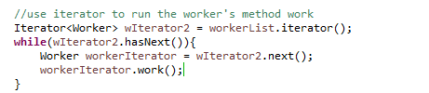

**5.6**

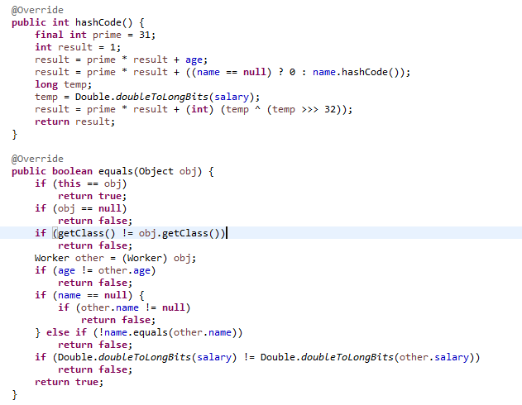

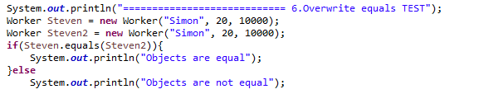

**5.7**

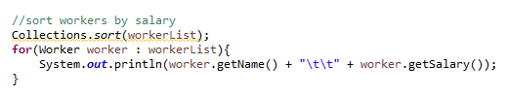

**5.8**

